CHAPTER THREE
DESIGN OF A VIRTUAL LIBRARY LEARNING PLATFORM FOR 300 LEVEL MANAGEMNET SCIENCE STUDENTS OF UNIVERSITY OF JOS
3.0 INTRODUCTION
This chapter describes the structure and components of the application, programming languages \used in development and justification for the use of those languages. The Virtual Library Learning Platform is built to make it possible for both instructors and learners to communicate and share information virtually. It also states the requirement and system design of the platform.
3.1 STRUCTURE OF THE PROPOSED SYSTEM
The Virtual Library Learning Platform is based on the Microservices Artitecture. According to Wolff (2016), Services in a Microservice Architecture are often processes that communicate over a network to fulfill a goal using technology-agnostic protocols such as HTTP. Services can be implemented using different programming languages, databases, hardware and software environments, depending on what fits best (Chen, 2018). The diagram below gives an overview of what a Microservice Architecture looks like.

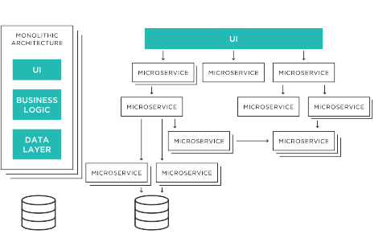

The VLLP mobile application provides an interface for users to interact with the Virtual Learning Platform System seamlessly. The image below shows what users see after successfull installation of the Mobile Application on an Android device.

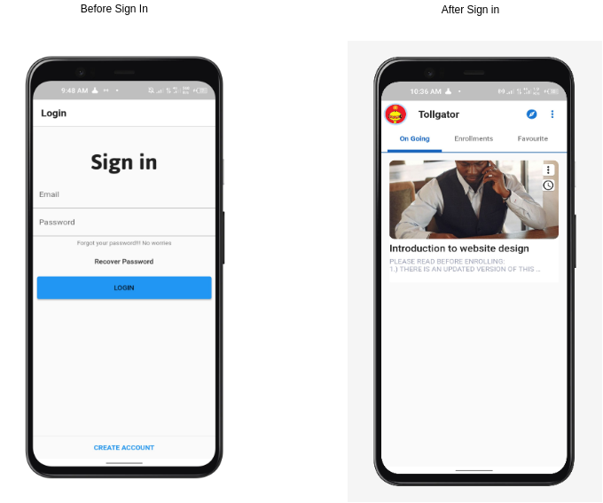
Using the Microservices Architecture, the Virtual Library Learning platform was broken down into functional services. For this services to communicate effectively, a Representational State Transfer(REST) Application Programming Interface (API) is used as the basis for communication between these services.

Interaction between User and Mobile Application Hardware

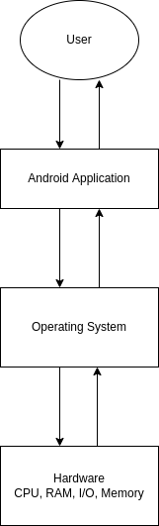

The major modules of this system are outlined below
- Backend module
This service serves the purpose of providing all required back-end functionalities for the effective running of the system. This includes; Course management, user data management, user registration, and information resource management. Its functionality is made available through a well-defined API accessible via HTTPS.
- Firebase authentication module
This service is based on the Google Firebase toolkit for mobile application development. It is used to handle all user authentication data and provide user-specific customization and real-time notifications.
- Student Front-end module
This module presents an interface users can interact with to access functionalities provided by the platform. This includes browsing a collection of courses uploaded by instructors, accessing freely available information resources uploaded, account creation and login functionalities. The Frontend module is available for desktop and mobile devices.
- Instructor Front-end module
This module presents an interface instructors interact with to access functionalities provided by the platform. This includes courses management, information resources upload, account creation and login functionalities. The Frontend module is available for desktop and mobile devices.

The Diagram Below shows the system structure

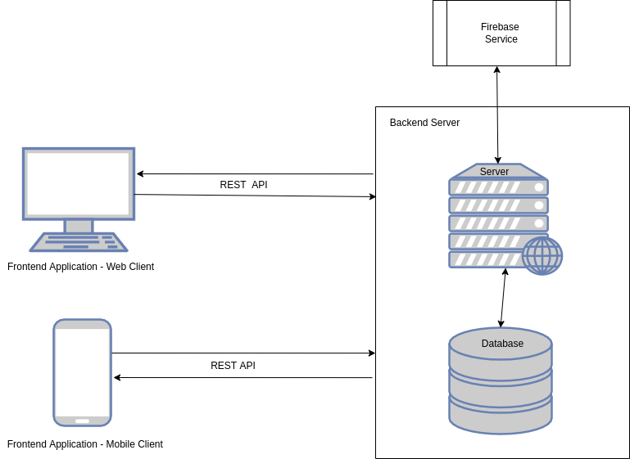

System Data flowchart
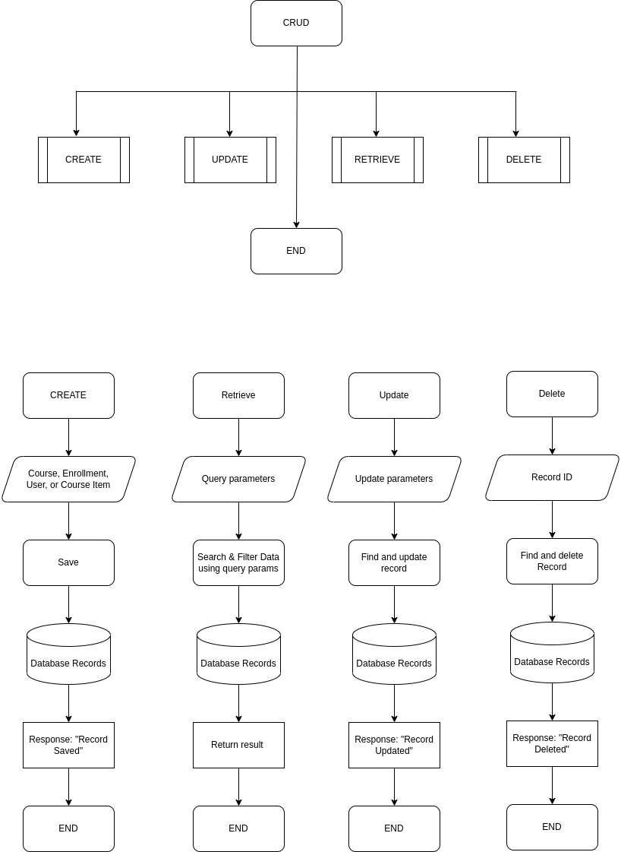
3.2 HARDWARE DESIGN MODEL
The proposed Virtual Library Learning Platform can be grouped into two parts. The server and the client. The server component of the platform is responsible for handling all business login that makes it possible for users to interact with the platform. The server component of the platform is hosted on an online server accessble via the internet. The client component of the platform are user managed devices which are personal computers and mobile devices. These clients communicate with the server via the internet.
To run the backend application on the Server-side. The following are the minimum hardware requirement:
- RAM: 512 MB
- NodeJs Server Software
- Heroku ephemeral storage
To run the frontend application on the Client-side The following are the minimum hardware requirement:
- RAM: Minimim of 512 MB
- Android, Windows, or Linux Operating System
- Mobile or Computer Device

Hardware Diagram

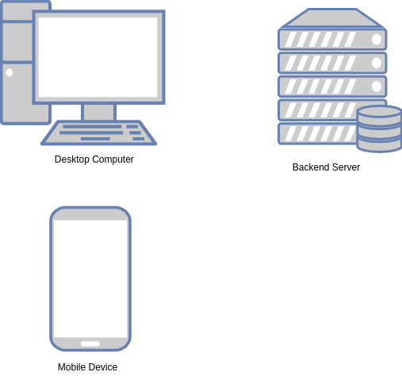

3.3 GUI (MOBILE APPLICATION) DESIGN MODEL
The Model-View-Controller design pattern was used in the development of the mobile application. Model–view–controller (MVC) is a software design pattern; commonly used for developing user interfaces that divide the related program logic into three interconnected elements. This is done to separate internal representations of information from the ways information is presented to and accepted from the user (Reenskaug, 2019). The VVLP Mobile Application is made up of pages, models and controllers which work together to appropriately represent data and provide a functional interface.

Mobile Application Screens
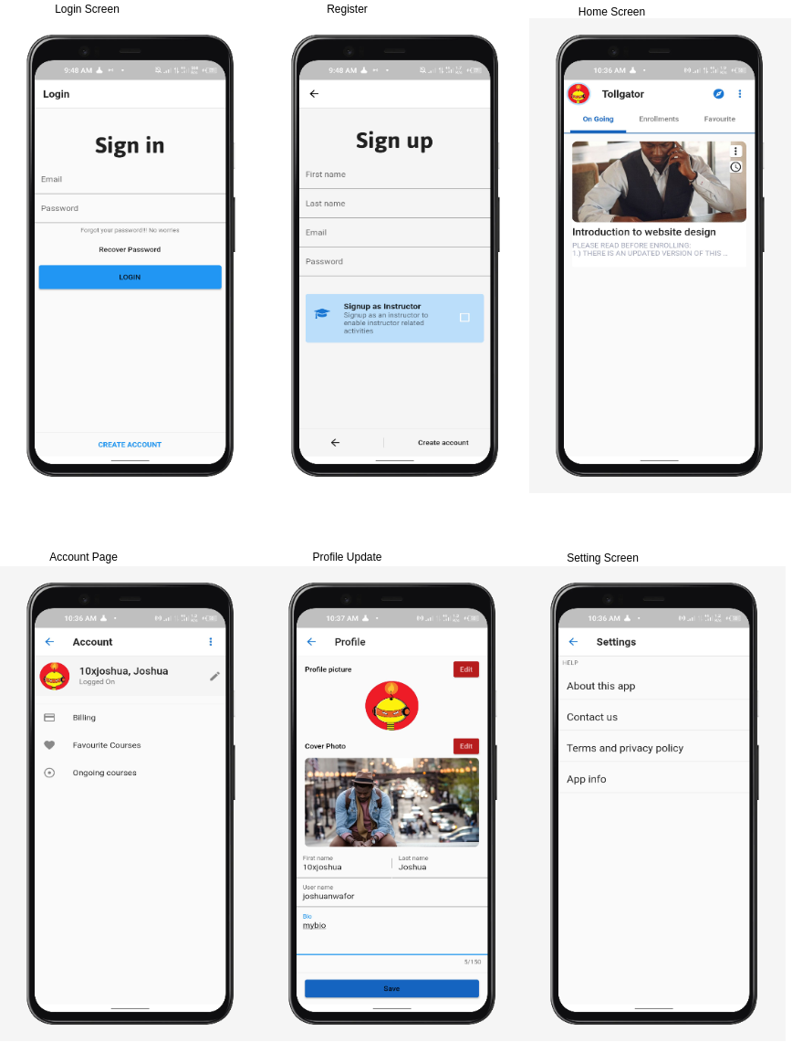

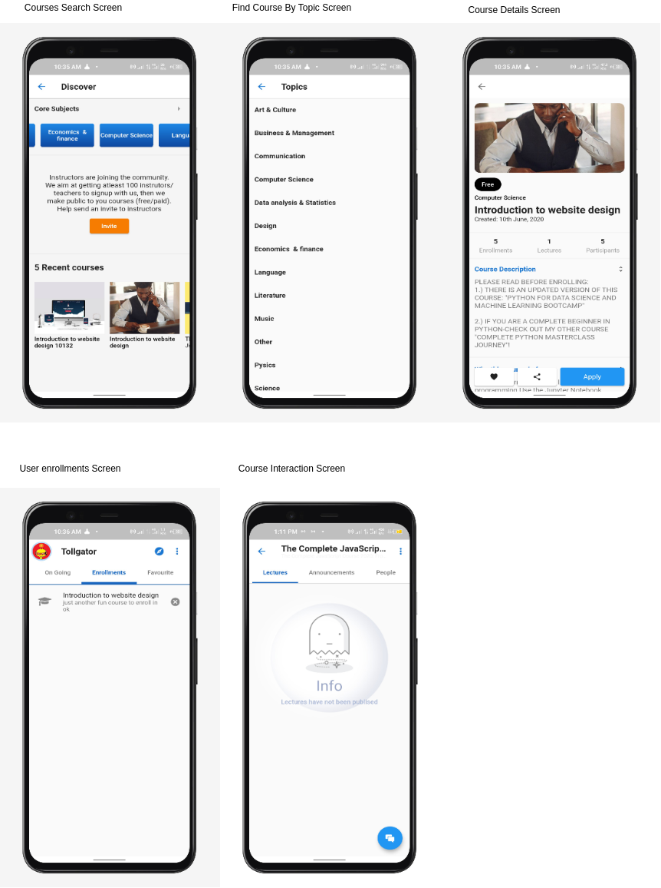

3.3.1 MOBILE APPLICATION COMPONENTS DESCRIPTION
The VLLP mobile application is made up of modules that work together to properly represent information to the user.
- Authentication module: The authentication module is responsible for authentication users in to the application, for users to be properly authenticated, they must create an account on the application. Account creation and management is handled by the Firebase authentication service. This module provides the login and registeration screen that makes it possible for users to get authenticated.
- User home module: The user home view provides a single entry point into other parts of the application. From this view, users can navigate to other routes in the application.
- User courses module: The user courses view is responsible for loading all courses which an authenticated user has enrolled in.
- Course search module: The course search module provides an interface for authenticated users to search courses available in the system and view information on those course.
- Course module: This module is responsible for presenting an interface to user to have access to course resoures, this includes course members, forums, and lessons.
- Course lesson module: The presents a view to users to intereact and make use of course resources. This could be a video, audio, or digital file resource.
- Course forum module: This module provides a view for users to interact with and access course forum resources. Resources in a course forum are messages published by members of a course.
- User profile module: The user profile module provides an interface where users can update and view their profile.
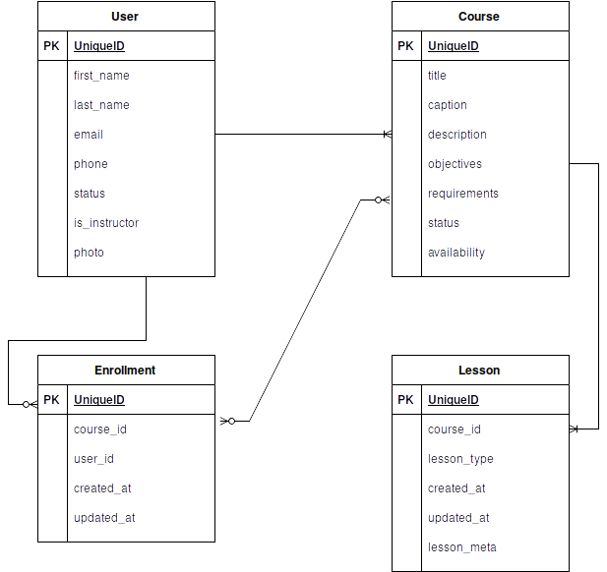
Entity Relationship Diagram

3.4 OPERATION OF THE PROPOSED SYSTEM
Representation of User roles and actions interacting with the system

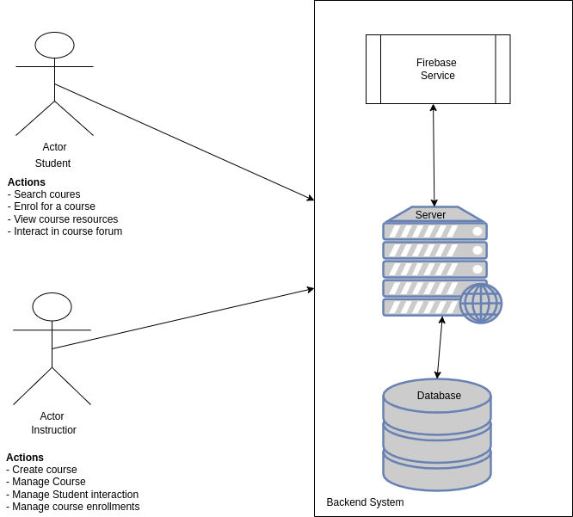

User Mobile Application Authentication Flow
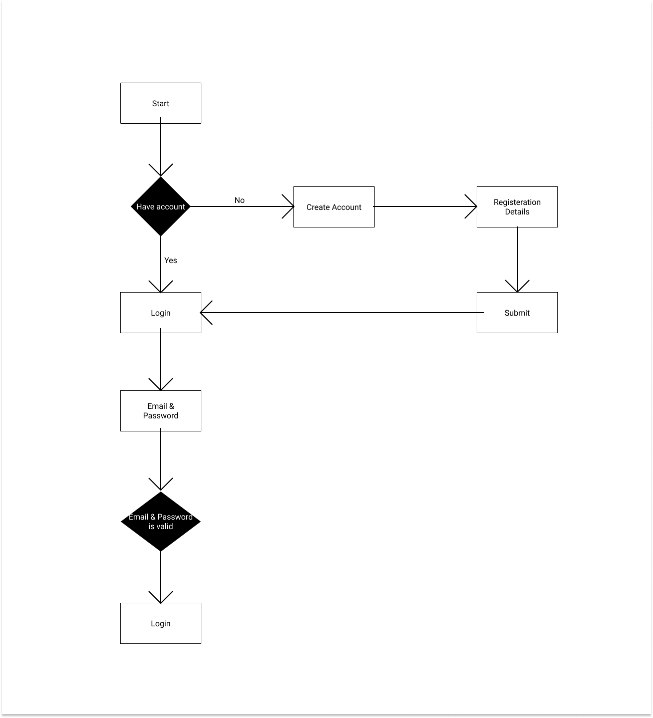

Representation of User interaction with mobile application

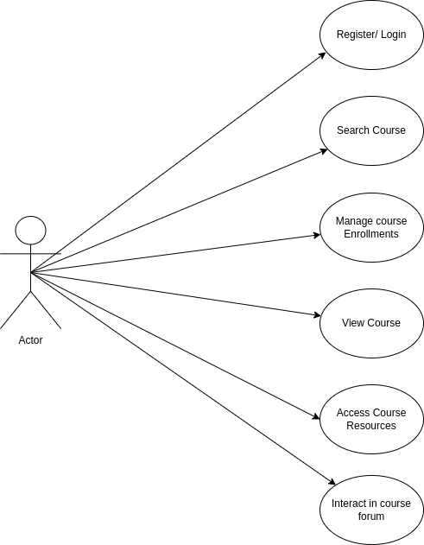

Authenticated User Dashboard flow
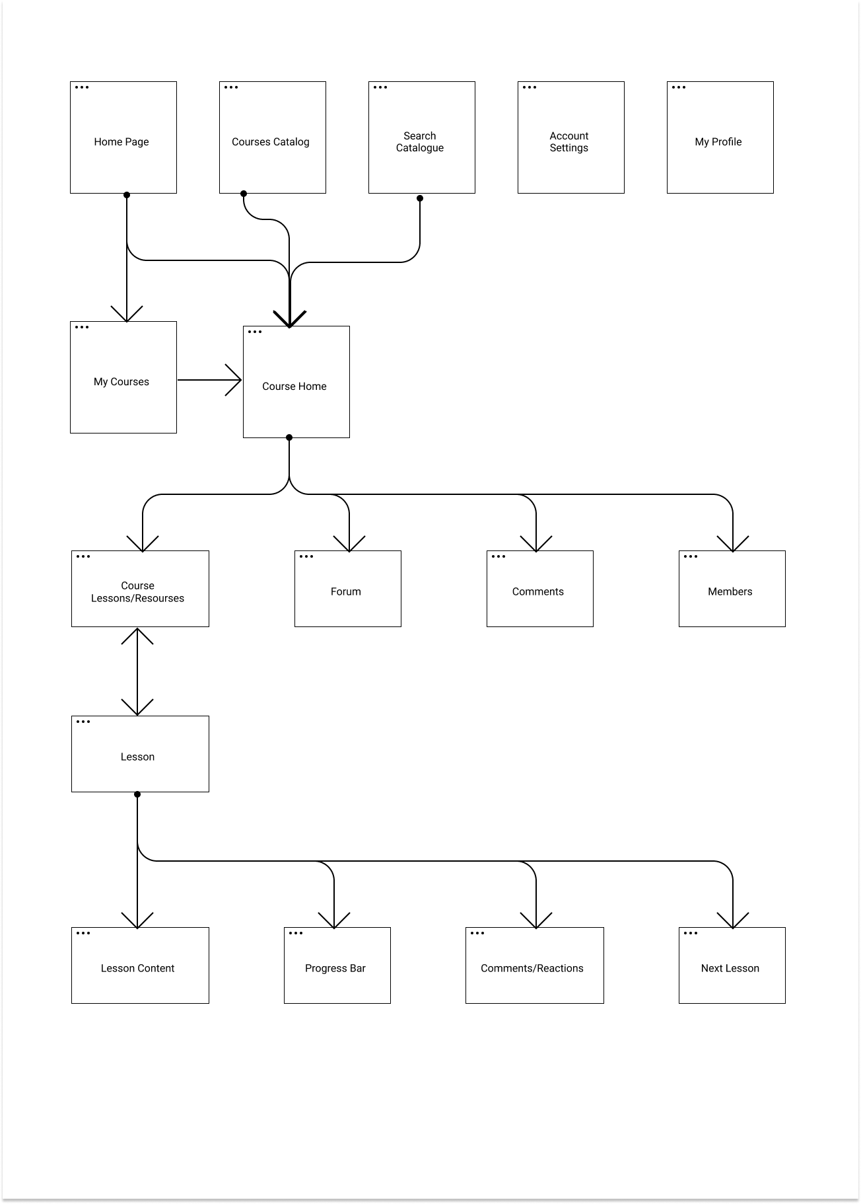
3.5 ADVANTAGES OF THE PROPOSED PLATFORM
- Learners can easily access course resources from the comfort of their phones.
- Course forum makes it possible for learners to as questions virtually and have answered buy fellow learners or the instructor realtime
- Instructors can easily manage resources and course enrollments.
- Instructors can reuse course resources for other sessions they would handle in the feature, this saves them the stress of publishing resources at the beginning of semesters
- Instructors can track the knowledge of learners by monitoring interaction on the course forum.
- The proposed system makes it possible for lecture sessions to hold irrective of wheather there’s an unforseen circumstance that hinders learners and instructors from being available physically.
3.6 PROGRAMMING LANGUAGE
Programming languages used are listed below;
- JavaScript Programming language
- Dart programming language
- HyperText Markup Language (HTML)
- Cascading Style Sheets (CSS)

3.7 LANGUAGE JUSTIFICATION
JavaScrript was choosed as the primary programming language for this project as it brings about somany advantagees. Looking at the fact that JavaScript can be used for backend and frontend development, it makes development faster as one langauge is being used accross major application modules. The Dart programming language was choosed to develop the mobile application as it poses several advanges. According to dart.dev (2021), Dart is a programming language designed for client development, such as for the web and mobile apps. It is developed by Google and can also be used to build server and desktop applications. HTML as the standard language for developing websites was used to build the platforms website.
According to Lozinski (2021), Uber Technologies uses JavaScript for frontend development including other programming languages such as Python, Go and Java. According to Ironhack (2021), LinkedIn relies on NodeJS for its mobile site; LinkedIn switched over to NodeJS to solve its scaling problems as the previous technology stack used (Rails application) was slow and hardly scalable.
3.8 CONCLUSION
This chapter summarised the structure and components of the Virtual Library Learning Platform, described the variouse languages used and justification for use and stated the requirement for systme use.

References
Dart.dev, (2021). Dart overview. Available at: https://dart.dev/overview.html
Chen, L (2018). Microservices: Architecting for Continuous Delivery and DevOps. Available at: https://www.researchgate.net/publication/323944215.
Reenskaug, T. & Coplien, J.O. (20 March 2009). The DCI Architecture: A New Vision of Object- Oriented Programming. Available at: https://web.archive.org/web/20090323032904/https://www.artima.com/articles/ dci_vision.html
Wolff, E (2016). Microservices: Flexible Software Architectures. ISBN 978-0134602417. Available at: https://en.wikipedia.org/wiki/Special:BookSources/978-0134602417The Uber
IronHack. (2021). How 10 Major Companies Are Using JavaScript. Available at: https://www.ironhack.com/en/web-development/10-major-companies-avascript
Lozinski, L. (2016). Engineering Tech Stack, Part II: The Edge and Beyond. Available at: https://eng.uber.com/uber-tech-stack-part-two/

CHAPTER 3
DESIGN OF A VIRTUAL LIBRARY LEARNING PLATFORM FOR 300 LEVEL MANAGEMNET SCIENCE STUDENTS OF UNIVERSITY OF JOS
3.0 INTRODUCTION
This chapter describes the structure and components of the application, programming languages used in development and justification for the use of those languages. The Virtual Library Learning Platform is built to make it possible for both instructors and learners to communicate and share information virtually. It also states the requirement and system design of the platform.
3.1 STRUCTURE OF THE PROPOSED SYSTEM
The Virtual Library Learning Platform is based on the Microservices Artitecture. According to Wolff (2016), Services in a Microservice Architecture are often processes that communicate over a network to fulfill a goal using technology-agnostic protocols such as HTTP. Services can be implemented using different programming languages, databases, hardware and software environments, depending on what fits best (Chen, 2018). The diagram below gives an overview of what a Microservice Architecture looks like.

The VLLP mobile application provides an interface for users to interact with the Virtual Learning Platform System seamlessly. The image below shows what users see after successfull installation of the Mobile Application on an Android device.

Using the Microservices Architecture, the Virtual Library Learning platform was broken down into functional services. For this services to communicate effectively, a Representational State Transfer(REST) Application Programming Interface (API) is used as the basis for communication between these services.

Interaction between User and Mobile Application Hardware

The major modules of this system are outlined below
- Backend module
This service serves the purpose of providing all required back-end functionalities for the effective running of the system. This includes; Course management, user data management, user registration, and information resource management. Its functionality is made available through a well-defined API accessible via HTTPS.
- Firebase authentication module
This service is based on the Google Firebase toolkit for mobile application development. It is used to handle all user authentication data and provide user-specific customization and real-time notifications.
- Student Front-end module
This module presents an interface users can interact with to access functionalities provided by the platform. This includes browsing a collection of courses uploaded by instructors, accessing freely available information resources uploaded, account creation and login functionalities. The Frontend module is available for desktop and mobile devices.
- Instructor Front-end module
This module presents an interface instructors interact with to access functionalities provided by the platform. This includes courses management, information resources upload, account creation and login functionalities. The Frontend module is available for desktop and mobile devices.

The Diagram Below shows the system structure

System Data flowchart
3.2 HARDWARE DESIGN MODEL
The proposed Virtual Library Learning Platform can be grouped into two parts. The server and the client. The server component of the platform is responsible for handling all business login that makes it possible for users to interact with the platform. The server component of the platform is hosted on an online server accessble via the internet. The client component of the platform are user managed devices which are personal computers and mobile devices. These clients communicate with the server via the internet.
To run the backend application on the Server-side. The following are the minimum hardware requirement:
- RAM: 512 MB
- NodeJs Server Software
- Heroku ephemeral storage
To run the frontend application on the Client-side The following are the minimum hardware requirement:
- RAM: Minimim of 512 MB
- Android, Windows, or Linux Operating System
- Mobile or Computer Device

Hardware Diagram

3.3 GUI (MOBILE APPLICATION) DESIGN MODEL
The Model-View-Controller design pattern was used in the development of the mobile application. Model–view–controller (MVC) is a software design pattern; commonly used for developing user interfaces that divide the related program logic into three interconnected elements. This is done to separate internal representations of information from the ways information is presented to and accepted from the user (Reenskaug, 2019). The VVLP Mobile Application is made up of pages, models and controllers which work together to appropriately represent data and provide a functional interface.

Mobile Application Screens

3.3.1 MOBILE APPLICATION COMPONENTS DESCRIPTION
The VLLP mobile application is made up of modules that work together to properly represent information to the user.
- Authentication module: The authentication module is responsible for authentication users in to the application, for users to be properly authenticated, they must create an account on the application. Account creation and management is handled by the Firebase authentication service. This module provides the login and registeration screen that makes it possible for users to get authenticated.
- User home module: The user home view provides a single entry point into other parts of the application. From this view, users can navigate to other routes in the application.
- User courses module: The user courses view is responsible for loading all courses which an authenticated user has enrolled in.
- Course search module: The course search module provides an interface for authenticated users to search courses available in the system and view information on those course.
- Course module: This module is responsible for presenting an interface to user to have access to course resoures, this includes course members, forums, and lessons.
- Course lesson module: The presents a view to users to intereact and make use of course resources. This could be a video, audio, or digital file resource.
- Course forum module: This module provides a view for users to interact with and access course forum resources. Resources in a course forum are messages published by members of a course.
- User profile module: The user profile module provides an interface where users can update and view their profile.
Entity Relationship Diagram

3.4 OPERATION OF THE PROPOSED SYSTEM
Representation of User roles and actions interacting with the system

User Mobile Application Authentication Flow

Representation of User interaction with mobile application

Authenticated User Dashboard flow
3.5 ADVANTAGES OF THE PROPOSED PLATFORM
- Learners can easily access course resources from the comfort of their phones.
- Course forum makes it possible for learners to as questions virtually and have answered buy fellow learners or the instructor realtime
- Instructors can easily manage resources and course enrollments.
- Instructors can reuse course resources for other sessions they would handle in the feature, this saves them the stress of publishing resources at the beginning of semesters
- Instructors can track the knowledge of learners by monitoring interaction on the course forum.
- The proposed system makes it possible for lecture sessions to hold irrective of wheather there’s an unforseen circumstance that hinders learners and instructors from being available physically.
3.6 PROGRAMMING LANGUAGE
Programming languages used are listed below;
- JavaScript Programming language
- Dart programming language
- HyperText Markup Language (HTML)
- Cascading Style Sheets (CSS)

3.7 LANGUAGE JUSTIFICATION
JavaScrript was choosed as the primary programming language for this project as it brings about somany advantagees. Looking at the fact that JavaScript can be used for backend and frontend development, it makes development faster as one langauge is being used accross major application modules. The Dart programming language was choosed to develop the mobile application as it poses several advanges. According to dart.dev (2021), Dart is a programming language designed for client development, such as for the web and mobile apps. It is developed by Google and can also be used to build server and desktop applications. HTML as the standard language for developing websites was used to build the platforms website.
According to Lozinski, (2021), Uber Technologies uses JavaScript for frontend development including other programming languages such as Python, Go and Java. According to Ironhack (2021), LinkedIn relies on NodeJS for its mobile site; LinkedIn switched over to NodeJS to solve its scaling problems as the previous technology stack used (Rails application) was slow and hardly scalable.
3.8 CONCLUSION
This chapter summarised the structure and components of the Virtual Library Learning Platform, described the variouse languages used and justification for use and stated the requirement for systme use.

References
Dart.dev, (2021). Dart overview. Available at: https://dart.dev/overview.html
Chen, L (2018). Microservices: Architecting for Continuous Delivery and DevOps. Available at: https://www.researchgate.net/publication/323944215.
Reenskaug, T. & Coplien, J.O. (20 March 2009). The DCI Architecture: A New Vision of Object- Oriented Programming. Available at: https://web.archive.org/web/20090323032904/https://www.artima.com/articles/ dci_vision.html
Wolff, E (2016). Microservices: Flexible Software Architectures. ISBN 978-0134602417. Available at: https://en.wikipedia.org/wiki/Special:BookSources/978-0134602417The Uber
IronHack. (2021). How 10 Major Companies Are Using JavaScript. Available at: https://www.ironhack.com/en/web-development/10-major-companies-avascript
Lozinski, L. (2016). Engineering Tech Stack, Part II: The Edge and Beyond. Available at: https://eng.uber.com/uber-tech-stack-part-two/

